**EECS 160LA Lab Report**

|  |  |
| --- | --- |
| Title | Lab 4: PI Controller Design for Speed Control |
| Day of Session | Friday 8-10:50 am |
| Student Name | Cameron Peterson-Zopf |
| Date of Submission | 11/15/24 |

# 

# Introduction/Objective

In this experiment we utilized step input and step response to extract the overshoot percentage and rise time of the system for different values of step input. Specifically, the step input increases from a 0 to 4 V square wave to a 0 to 4.5 V square wave. We learned how to determine the rise time and overshoot values through the step response. This analysis was applied to a DC motor’s response to the step input, with the controller having PI control.

# Discussion

For this experiment, the group will use PI, or proportional and integral, control for the DC motor. We will construct the following circuit shown in figure 1.

**Figure 1:** Block Diagram of Motor and Driver w/ PI Control

Then, step inputs of 4 V and 4.5 V will be applied, with the overshoot and rise time computed from the graphs generated on an oscilliscope. These results were tabulated in table 1.

|  |  |  |  |  |
| --- | --- | --- | --- | --- |
| Ref Volt (V) | Overshoot (V) | Overshoot % | Rise Time tr (msecs) | Saturation Value (V) |
| 4 | 48.5 | 21.250% | 590 | 40 |
| 4.5 | 54.125 | 21.972% | 560 | 44.375 |

As seen from the table above, the overshoot percentage and rise time remained roughly constant, which was expected.

**Lab Questions:**

**Question #1:**

*Model Fig. 1 in MATLAB using the values of KP and KI you used in the lab (0.215 and 3.04 s^-1 respectively). Assume C1 = 10 and C2 = 0.6s. Your goal for the design was a rise time of 0.8s and an overshoot of 20%. How do you measure the overshoot and rise time of the resulting step response? Show how you make these measurements on the simulated step response. Explain any differences between the expected rise time and overshoot and the simulation results.*

The overshoot and rise time were measured by MATLAB’s “step” function to graph the output, and then cursors to determine the max point, 90% of the steady state value, and 10% of the steady state value as shown below:

From the graph, the max amplitude is at 48.3 V, the time where we reach 90% of the steady state value is 0.829 seconds, and the time it takes to reach 10% of this value is 0.154 seconds. Thus, the theoretical rise time is 0.675 seconds, or 675 ms. Furthermore, the overshoot is calculated with the following formula:

The theoretical rise time is below the desired time of 800 ms and the overshoot percentage is slightly above the desired result of 20%. The high overshoot percentage may be due to errors from rounding. The rise time being lower can also be due to rounding errors but also due to the design constraints for the overshoot.

**Question #2:**

*What was the overshoot and rise time you measured in the experiment (for 4V and 4.5V inputs)? Attach plots from the scope showing the measurement of the rise time and overshoot.*  
For 4V step input the rise time was 590 ms and the overshoot percentage was 21.250%. For 4.5 V the rise time was 560 ms and the overshoot percentage was 21.972%.

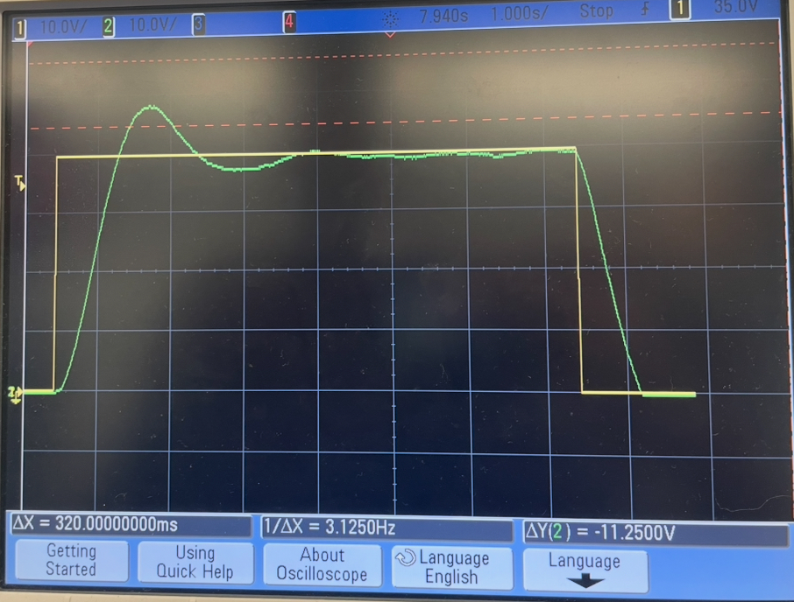

**Plot 1:** Plot for 4V step input.

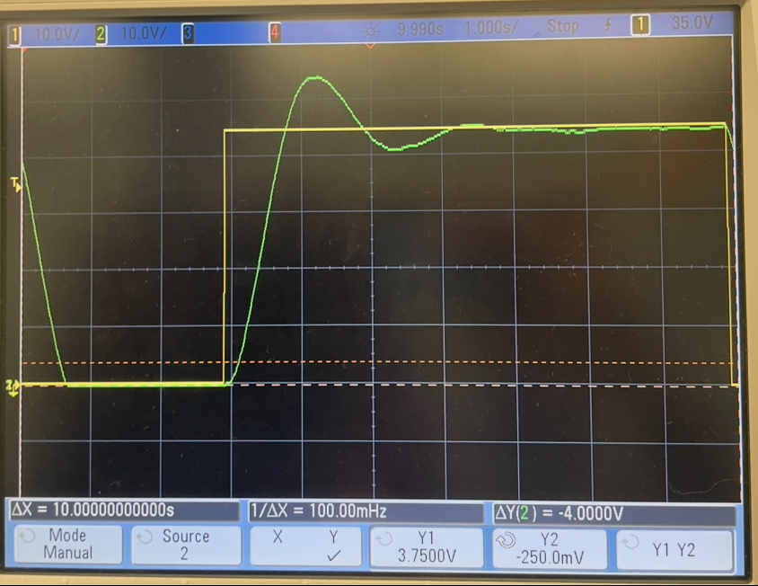

**Plot 2:** Plot for 4.5V step input.

**Question #3:**

*In an ideal system, would the overshoot and rise time be different for different input voltages?*  
*Explain why or why not.*  
The rise time and overshoot percentage should not change due to the input. Rise time is inversely proportional to the natural frequency. The natural frequency is calculated from the transfer function, which is the same regardless of input voltage, and hence the rise time should be constant. The overshoot percentage is calculated with the dampening ratio zeta, a variable also derived from the transfer function and should also be constant.

**Question #4:**

*Were the overshoot and rise time you measured different for different input voltages? Explain*  
*why or why not.*  
Yes, as seen from Table 1 in this report, the rise times and overshoots were different for different inputs. However, they weren’t different by that much. The overshoot percentage only varied by less than a percentage point, and the rise time varied by only 30 ms. Likely causes for the deviations are due to measurement errors both by the equipment and from manual cursor inspection. The non-ideal nature of the system can also contribute to the deviation as other components not accounted for may change with voltage.

**Question #5:**

*Do your experimental results and simulation results match? Explain why or why not.*

The experimental results roughly match the simulated results. The simulated overshoot percentage was 20.75%, whereas the actual was around 21.5%. The simulated rise time was 675 ms, compared to the experimental of 575 ms on average. The rise times are more different than each other than the overshoots are. Due to resistance tolerances, imperfect DC motor and cable connections, and rounding problems in the cursors of the oscilloscope, these differences of values are reasonable. The comparison of a non-ideal system to an ideal system is also a reason as there are factors that influence the output of the non-ideal system.

# Conclusion

In this experiment we described how changes in step input of a circuit with a DC motor affect the output response of that motor, specifically how these changes affect the overshoot percentage and rise time. Ideally, we expected the rise time and overshoot percentage to be invariant to the input. Rise time is inversely proportional to the natural frequency, and the natural frequency is dependent on the transfer function, not the input. Thus, the rise time should theoretically be constant. However, due to imperfections in the DC motor and noise, the rise time changed slightly. Furthermore, the overshoot percentage is dependent on the dampening ratio zeta, a parameter that is also dependent solely on the transfer function. However, due to the same reasons as before, the imperfections in the DC motor and noise, the overshoot percentage did change slightly with a change in input. We analyzed these parameters in physics circuits while in lab, and through simulations done by MATLAB. The results from both roughly aligned with each other, and the difference between the two is due to the errors discussed previously.